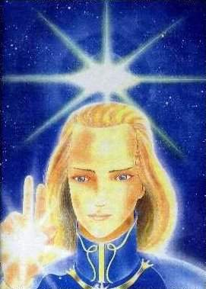
ASHTAR SHERAN – spiritual being of higher consciousness, a brother full of love and humility, helping the souls’ elevation. Commander of a cosmic squadron of 10 millions spaceships with the command on the Cosmic station SHARE. www.universe-people.com

